**[24] Design DFA Which Consists of Sub String ‘AB’**

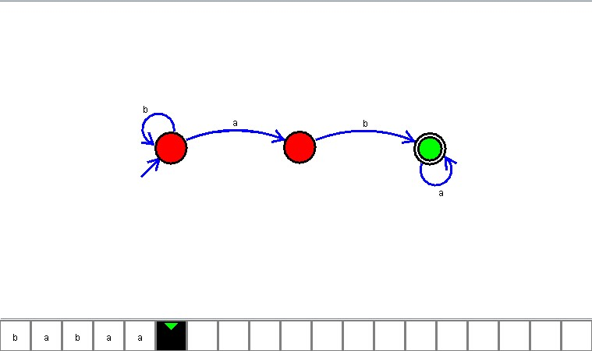

**Result**

The DFA is designed to compute the strings as input using Automaton Simulator